**Part 1: The Challenge**

**Organising and describing the data**

|  |  |  |  |
| --- | --- | --- | --- |
| **Symbol** ​ | **Meaning** ​ | **Type** ​ | **Active Logic** ​ |
| DRIV ​ | Driver is in the seat ​ | Input ​ | HIGH (1 = present) ​ |
| PASS ​ | Passenger is in the seat ​ | Input ​ | HIGH (1 = present) ​ |
| IGN ​ | Ignition switch is ON ​ | Input ​ | HIGH (1 = on) ​ |
| $\sim BELTD$ ​ | Driver’s seatbelt unfastened ​ | Input ​ | LOW (0 = unfastened) ​ |
| ​~BELTP | Passenger’s seatbelt unfastened ​ | Input ​ | LOW (0 = unfastened) ​ |
| ~ALARM ​ | Alarm signal (active LOW = sounds when 0) ​ | Output ​ | LOW = ON ​ |

**Designing the Solution**

**Algorithm**

Monitor ignition status:- IGN must be HIGH

Check if driver seat is occupied and seat belt is not fastened: -

DRIV= 1 AND $\overline{BELTD}$ = 0

Check if passenger seat is occupied and seat belt is not fastened: -

DRIV= 1 AND PASS =1 AND $\overline{BELTP}$ = 0

If either of the condition is TRUE and IGN =1 , the alarm activates LOW.

Otherwise, the alarm remains HIGH.

**Truth Table**

Possible combinations= 2^n = 2^4 = 16 [n= inputs; IGN is always 1 so not considering it]

|  |  |  |  |  |  |
| --- | --- | --- | --- | --- | --- |
| DRIV | PASS | $$\overline{BELTD}$$ | $$\overline{BELTP}$$ | IGN | ALARM^ |
| 0 | 0 | 0 | 0 | 1 | 1 |
| 0 | 0 | 0 | 1 | 1 | 1 |
| 0 | 0 | 1 | 0 | 1 | 1 |
| 0 | 0 | 1 | 1 | 1 | 1 |
| 0 | 1 | 0 | 0 | 1 | 1 |
| 0 | 1 | 0 | 1 | 1 | 1 |
| 0 | 1 | 1 | 0 | 1 | 1 |
| 0 | 1 | 1 | 1 | 1 | 1 |
| 1 | 0 | 0 | 0 | 1 | 0 |
| 1 | 0 | 0 | 1 | 1 | 0 |
| 1 | 0 | 1 | 0 | 1 | 1 |
| 1 | 0 | 1 | 1 | 1 | 1 |
| 1 | 1 | 0 | 0 | 1 | 0 |
| 1 | 1 | 0 | 1 | 1 | 0 |
| 1 | 1 | 1 | 0 | 1 | 0 |
| 1 | 1 | 1 | 1 | 1 | 1 |

Turning Truth Tables to Boolean Expressions

ALARM^ = DRIV. PASS^ . $\overline{BELTD}$. $\overline{BELTP}$. IGN + DRIV. PASS^ . $\overline{BELTD}$. $BELTP$. IGN + DRIV. PASS. $\overline{BELTD}$. $\overline{BELTP}$. IGN + DRIV. PASS. $\overline{BELTD}$. $BELTP$. IGN + DRIV. PASS. BELTD. $\overline{BELTP}$. IGN

Flow Chart

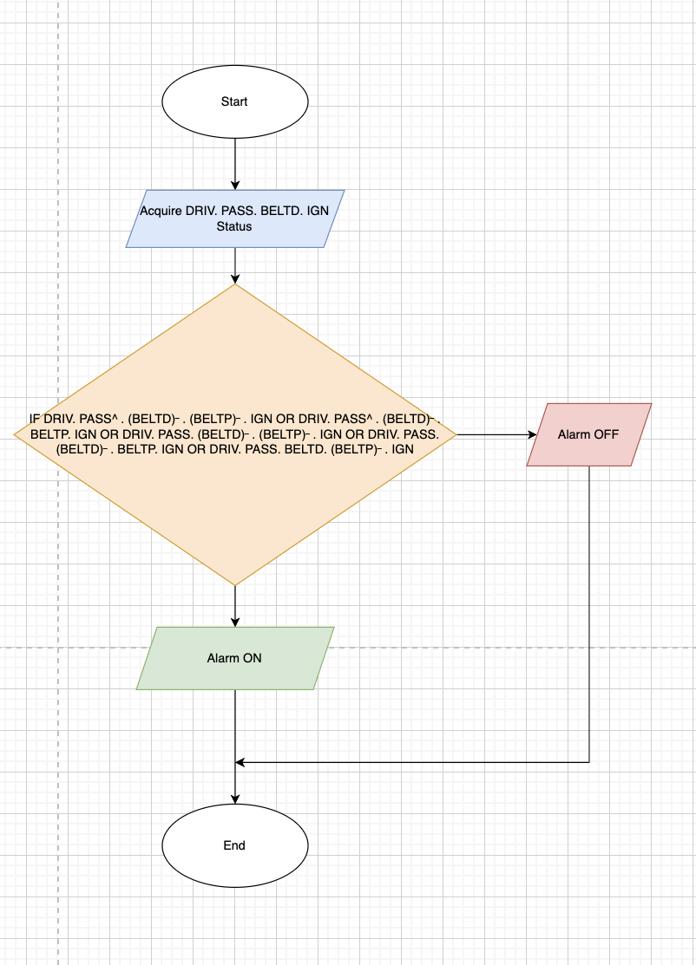

**Pseudocode**

IF (DRIV∙(PASS) ̅∙(BELTD) ̅∙(BELTP) ̅∙IGN) OR​

(DRIV∙(PASS) ̅∙(BELTD) ̅∙BELTP∙IGN) OR​

(DRIV∙PASS∙(BELTD) ̅∙(BELTP) ̅∙IGN) OR​

(DRIV∙PASS∙(BELTD) ̅∙BELTP∙IGN) OR ​

THEN ALARM = 0 # ON​

ELSE ALARM = 1 # OFF

**Test and Refine the Solution**

|  |  |  |  |  |  |  |
| --- | --- | --- | --- | --- | --- | --- |
| DRIV​ | PASS​ | BELTD^​ | BELTP^​ | IGN​ | ALARM^ (expected)​ | ALARM^ (obtained)​ |
| 0​ | 1​ | 1​ | 1​ | 1​ | 1​ | 1​ |
| 1​ | 0​ | 0​ | 0​ | 1​ | 0​ | 0​ |
| 1​ | 0​ | 0​ | 1​ | 1​ | 0​ | 0​ |
| 1​ | 0​ | 1​ | 1​ | 1​ | 1​ | 1​ |
| 1​ | 1​ | 0​ | 0​ | 1​ | 0​ | 0​ |
| 1​ | 1​ | 0​ | 1​ | 1​ | 0​ | 0​ |
| 1​ | 1​ | 1​ | 0​ | 1​ | 0​ | 0​ |

**Refining Pseudocode Logic using AI**

Prompts Provided to make the pseudocode better: -

*“Refine the pseudocode in a cleaner and understandable form that is structured but doesn’t lose its meaning.”*

BEGIN

INPUT DRIV // Driver seat occupied (1 = Yes, 0 = No)

INPUT PASS // Passenger seat occupied

INPUT BELTD // Driver seatbelt fastened (1 = Yes, 0 = No)

INPUT BELTP // Passenger seatbelt fastened

INPUT IGN // Ignition ON

IF IGN = 1 THEN

IF (DRIV = 1 AND BELTD = 0) OR

(PASS = 1 AND BELTP = 0) THEN

ALARM ← 0 // Alarm ON (LOW)

ELSE

ALARM ← 1 // Alarm OFF (HIGH)

ENDIF

ELSE

ALARM ← 1 // Ignition OFF → No alarm

ENDIF

OUTPUT ALARM

END